**Document to Run the Project :**

1. Import the project as Maven project.
2. Wait for Dependencies .
3. Now right click on PFRunner .java and mouse haover to RUN AS and click on Junit.

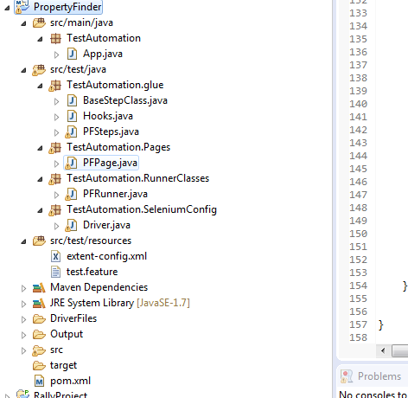

1. To see the result Please check the Out Put folder.
2. Screen shot will be displayed .